Berkshire East/ Thunder Mountain – Example Trip Plans & Packing List

2025:

Weather: Weather forecast is looking good - but chilly. So be prepared and have layers! Forecast is for Partly Cloudy/Sunny weather, high of 49 degrees on Saturday, and 50 on Sunday. At night the temps will drop to 31 degrees, so lets make sure everyone has a warm sleeping bag, down puffy jacket, pants, socks, some warm shoes/boots. Bring a hat/gloves. Full packing list is below.
Food: Here are the details for food arrangements. Scouts will be fed by Chef Stone Redness. He’s planning to bring food for Saturday’s Dinner, and Sundays’ breakfast. At the mountain there is at least one restaurant/snack bar - - so I’d recommend bring some cash or a credit card if you want to hit the base lodge food options. Bring some snacks if you want, ie Apple, Orange/Clementine, energy bars, that way you can refuel through the day. Bring a water bottle or camel back for those riding.
- Saturday Breakfast - - Eat before drop-off, or bring something for the car ride up.
- Saturday Lunch - - Pack a lunch to be eaten around 12:30pm. Or you can buy food at the base lodge
- Saturday Dinner - - Stone will cook up Steak for the Boys, at the Campsite.
- Sunday Breakfast - - Stone will cook up Breakfast - believe it’s Eggs at the campsite around 8:00am
- Sunday Lunch (*for mountain bikers staying) - - Plan to buy lunch at Base Lodge.
The Taqueria will be open - - here’s the menu
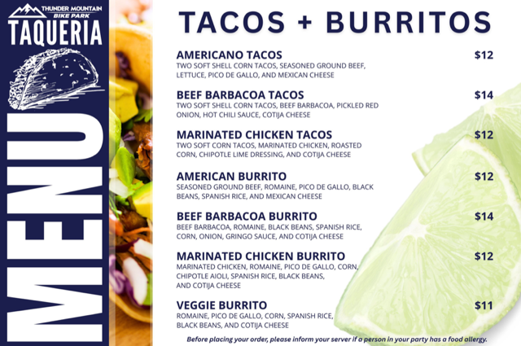
BE_Taqueria Menu 2025
PDF Document · 1.9 MB

Timing: We’ll have an early start Saturday - - Zip Lining starts at 9:00am, and we need to get to the base lodge by 8:40 to get checked in. Travel up to Thunder Mountain should take roughly 2:00-2:15 hours, with no traffic. So we plan to meet at the Exit 42 Parking lot at 6:00am sharp and plan to roll out at 6:10am Sharp! Allowing us time to comfortably get up to Massachusetts.
Saturday:
- 6:00am - Meet at Exit 42 Merrit Commuter lot. We will roll out at 6:10am after putting bags/gear into the two cars that are going up.
- 8:40am - Zip Line people will proceed to meeting area, to check in and start their adventure
- 9:00am - Mountain bikers will proceed to Rental shop to rent bikes/get pads/helmet and get Lift Ticket
- 12:30 - Plan to meet for lunch at base lodge
- 1:30 - Aerial Adventure Park Starts
- 4:00-5:00pm - Mountain Biking Ends, probably getting dark by then… Head to camp grounds to setup tents, prep for dinner.
- 5:00-8:00pm - Chill out at campsite, have campfire, eat and get ready for bed.
Sunday: **** Daylight savings begins, so we gain 1 hour of sleep. So it’ll be lighter in the morning, darker in the afternoon
- 7:00-8:30am - Cook breakfast, eat and start to tidy up the campsite, breakdown tents, pack things up.
- 8:30 - 9:00am - People not staying/mountain biking will head back to Westport CT. Matt’s car and Alex’s Mom will arrive to transport
- 9:00-1:30am - Mountain bike! Then have some lunch
- 2:00-2:30 - - Pack up and drive back to Connecticut.
- 5:00pm - Plan to arrive back in CT, Exit 42 for Drop off, Will text group ETA en route.

Packing List:
Group Gear - - This gear will be picked up prior to our trip and distributed to the scouts when we arrive at Thunder.
2 and 3 Person REI Tents
Camping Stove/Propane Tanks
Firewood, Marshmallows/S’mores, Hot Cocoa mix….
Chuck box with utensils, and cooking gear
First Aid Kit
Some Lights
If you need anything else out of the trailer please let me know tonight/tomorrow morning. I’m going to load up gear Friday mid-day.
Personal Pack List - - -
- Winter hat
- Winter gloves
- Sunglasses
- Socks (2 pairs, wool or wool blend for nighttime, Cotton/Sport fine for daytime)
- Underwear (2-3 pairs)
- Long Underwear (1 pair, silk, synthetic, or wool blend)
- Spare pants (1) - trail pants
- Base layer shirts (2) - synthetics, etc. NOT cotton.
- Fleece top or sweatshirt (1) - synthetics. NOT cotton.
- Hiking boots - or something warm for nighttime
- Jacket / Shell
- Sleepwear (1)
- Toiletries kit - Keep it basic. - Toothbrush/Paste, Deodorant etc.
- Toilet paper supply in a ziplock
- Water bottle(s) - At least one 1 L bottle. 2 L is better. Camelback for mountain bikers if wanted.
- Sunscreen might be good to have, Mountain bikers will be mostly covered up w/ gear/helmet.
- Pocket knife (Only if you have earned Totin’ Chit)
- Headlamp and spare batteries
- Personal first aid kit
- Mess kit
- Utensils
- Cup/mug
- Sleeping pad - - so you’re not sleeping on the ground, will help you stay warm
- Sleeping bag - rated to 20 degrees - Can supplement with liner to add warmth.
- Camp pillow or use bag of clothes
- Duffle Bag or Backpack - You should be able to pack all of the above inside.

Travel Arrangements:
Car Pool to be arranged by scouts/parents and leaders traveling up/ back.

